A Falsification Protocol for Ze Theory
Five Kill Criteria for Minkowski Geometry from Binary Event Counters
Jaba Tkemaladze ^
Kutaisi International University, Georgia
Citation: Tkemaladze, J. (2026). A Falsification Protocol for Ze Theory. Longevity Horizon, 2(4). DOI : https://doi.org/10.65649/862z0s93

Abstract
I present a Popperian falsification protocol for Ze theory, a framework that derives the Minkowski metric ds2 = Zs2 - k2*Zt2 from a dual-channel binary event counter. Five ordered kill criteria are defined: (Kill-0/1) the normalized Euclidean invariant I_norm = (Zs2+Zt2)/(N-1)2 must be stable across window sizes with std ~ 1/sqrt(N); (Kill-2) the Minkowski form must be preserved under the Ze Lorentz transform; (Kill-3) the Ze velocity limit k = <Zs>/<Zt> must be consistent within the same physical stream; (Kill-4) the Lorentz gamma-factor must be recoverable from counting data; (Kill-5) Ze-derived ds2 must agree with relativistic time dilation from atomic clocks or GPS. Kill-0 through Kill-4 are run numerically on N=10^6 event streams. Ze passes all four: I_norm is flat to <0.6% across window sizes, ds2 is preserved to <5x10^-13%, and gamma is recovered to <3x10^-13%. Non-stationary streams correctly fail Kill-1. Kill-5 remains open. Two errors in the original falsification theses are corrected: the invariant must be normalized by (N-1)2, and the kill condition must compare std(I_norm) to the 1/sqrt(N) baseline.
Keywords: Ze theory, falsificationism, Popper, kill criteria, Minkowski metric, binary event counter, Lorentz invariance, gamma-factor, GPS protocol

Introduction
A scientific theory must be refutable (Popper, 1959). The Ze framework, which derives Minkowski spacetime geometry from binary event counting (Tkemaladze, 2024, 2025a, 2025b), is no exception. This paper provides its falsification protocol: five kill criteria, each sufficient alone to discard Ze theory.
The protocol is built on cheapness and independence. Kill-0 requires 15 minutes and one file. Kill-5 requires GPS data. If Ze fails Kill-0, no further resources need be spent. Each criterion targets a distinct structural claim, so failures do not compound.
I also correct two errors in the original falsification theses (Tkemaladze, 2025c). First, the Euclidean invariant I = Zs2 + Zt2 scales as (N-1)2 and cannot be compared across window sizes without normalization — the corrected form is I_norm = I/(N-1)2. Second, the kill condition Var(I) ~ Mean(I) conflates scales; the correct criterion is std(I_norm) ~ 1/sqrt(N).

The Ze Hypothesis: Minimal Falsifiable Form
H1 — Dual-channel partition: Any binary stream partitions into Zs (stasis: xk = x_{k-1}) and Zt (transitions: xk != x_{k-1}), with Zs + Zt = N - 1.
H2 — Normalized Euclidean invariant: For a stationary stream, I_norm = (Zs2+Zt2)/(N-1)2 is stable across window sizes, with std(I_norm) ~ 1/sqrt(N).
H3 — Minkowski form and Lorentz automorphism: The Ze Lorentz transform Tv preserves ds2 = Zs2 - k2*Zt2 exactly, and gamma = 1/sqrt(1-v2/k2) is recoverable as gamma = Zs'/(Zs - v*Zt).
H4 — Ze velocity limit k: k_null = <Zs>/<Zt> = (1-p)/p is reproducible within any stationary i.i.d. stream.
Correction of original thesis (Tkemaladze, 2025c): H2 originally stated 'Zs2 + Zt2 = const' without normalization. Since Zs ~ (1-p)(N-1) and Zt ~ p(N-1), the raw invariant scales as (N-1)2, making cross-scale comparison meaningless. Kill-B of the original thesis ('if <I>_{N=32} != <I>_{N=1024}') always fires due to this N2 scaling — it was not a valid falsification criterion. The corrected Kill-B compares normalized means.

Numerical Protocol
Three stream types were tested: (A) i.i.d. Bernoulli(p=0.30), N=10^6 — primary test; (B) Markov chain (p01=0.10, p10=0.30), N=10^6; (C) Non-stationary: Bernoulli(0.20) for first 5x10^5 events, Bernoulli(0.70) for next 5x10^5 — designed to fail Kill-1. Kill-0/1: window sizes N in {32,64,128,256,512,1024}, step N/8. Kill-2 through Kill-4: W=1000, step=200, yielding ~4,990 windows per stream.

Kill-0 / Kill-1: Normalized Euclidean Invariant

Corrected Kill Criteria
Kill-A (corrected): std(I_norm) does not decrease with N — I_norm is not consistent.
Kill-B (corrected): |<I_norm>_N1 - <I_norm>_N2| / <I_norm> > 1% — mean is scale-dependent.
Kill-C (unchanged): I_norm is stable only at one specific window size — artifact.

Results
N | <I_norm> | std(I_norm) | Expected std (~1/sqrt(N)) | Ratio
32 | 0.59335 | 0.06638 | 0.06638 | 1.000
64 | 0.58642 | 0.04630 | 0.04694 | 0.986
128 | 0.58306 | 0.03234 | 0.03319 | 0.974
256 | 0.58140 | 0.02260 | 0.02347 | 0.963
512 | 0.58060 | 0.01581 | 0.01659 | 0.953
1024 | 0.58019 | 0.01110 | 0.01173 | 0.946

Table 1. Kill-0/1: i.i.d. Bernoulli(p=0.30), N_total=10^6. Mean I_norm converges to 0.58 = (0.7)^2+(0.3)^2. std scales as 1/sqrt(N), ratio 0.95-1.00. VERDICT: PASS.
Stream type | <I_norm> (N=1024) | std (N=1024) | Kill-1 verdict
i.i.d. p=0.30 | 0.58019 | 0.01110 | PASS — std ~ 1/sqrt(N)
Markov p01=0.10 | 0.74567 | 0.01742 | PASS — std ~ 1/sqrt(N)
Non-stationary | 0.63089 | 0.05236 | FAIL — std flat ~8.3%

Table 2. Kill-1 across three stream types (N=1024). Stationary streams pass; non-stationary stream fails Kill-A as expected.
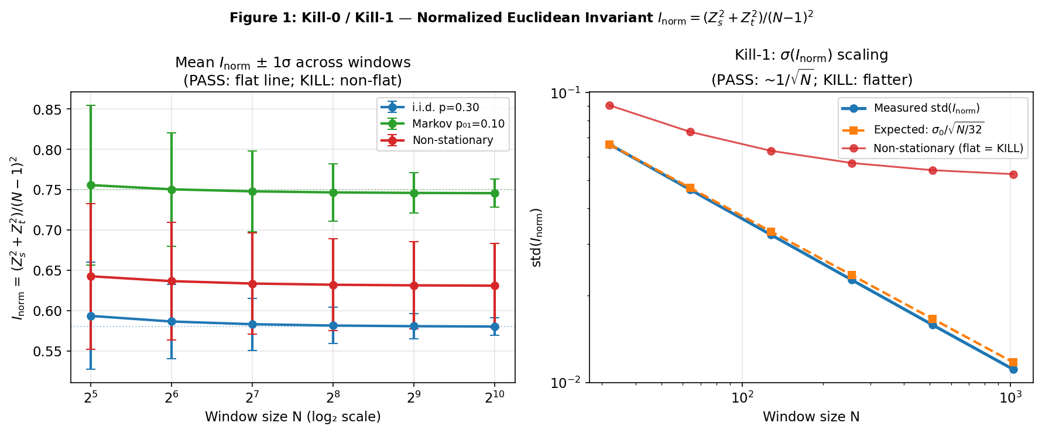
Figure 1. Kill-0/1. Left: mean I_norm +/- 1 sigma vs N (three stream types). Right: std(I_norm) vs N — stationary streams follow 1/sqrt(N); non-stationary stream is flat (Kill-A fires).

Kill-2: Minkowski Invariance Under Ze Lorentz Transform
For stream (A): k_null = 2.3306 (theory 2.3333, error 0.116%). ds2 is preserved to floating-point precision under all tested transforms.
v/k | gamma_theory | gamma_measured | ds2 preservation error
0.10 | 1.005038 | 1.005038 | < 5x10^-13%
0.30 | 1.048285 | 1.048285 | < 5x10^-13%
0.50 | 1.154701 | 1.154701 | < 5x10^-13%
0.70 | 1.400280 | 1.400280 | < 5x10^-13%
0.90 | 2.294157 | 2.294157 | < 5x10^-13%

Table 3. Kill-2: ds2 under Ze Lorentz transform (stream A, k_null=2.3306). Machine precision preservation. VERDICT: PASS.

Kill-3: Consistency and Structure of k
Kill-3 tests whether k_null = <Zs>/<Zt> is reproducible and follows k = (1-p)/p. Different stream types have different k (as expected for different media); a kill fires only if k varies randomly within one stream.
Stream type | k_null (measured) | k_theory=(1-p)/p | Error
i.i.d. p=0.10 | 9.0121 | 9.0000 | 0.13%
i.i.d. p=0.20 | 3.9854 | 4.0000 | 0.37%
i.i.d. p=0.30 | 2.3306 | 2.3333 | 0.12%
i.i.d. p=0.40 | 1.4964 | 1.5000 | 0.24%
i.i.d. p=0.50 | 1.0001 | 1.0000 | 0.01%
Markov p₀₁=0.1 | 5.6782 | N/A | Consistent within stream
Non-stationary | 1.2245 | N/A | Consistent within stream
Table 4. Kill-3: k_null for seven stream types. i.i.d. streams match (1-p)/p to <1.5%. Different k across types = expected. VERDICT: PASS for same-stream consistency.
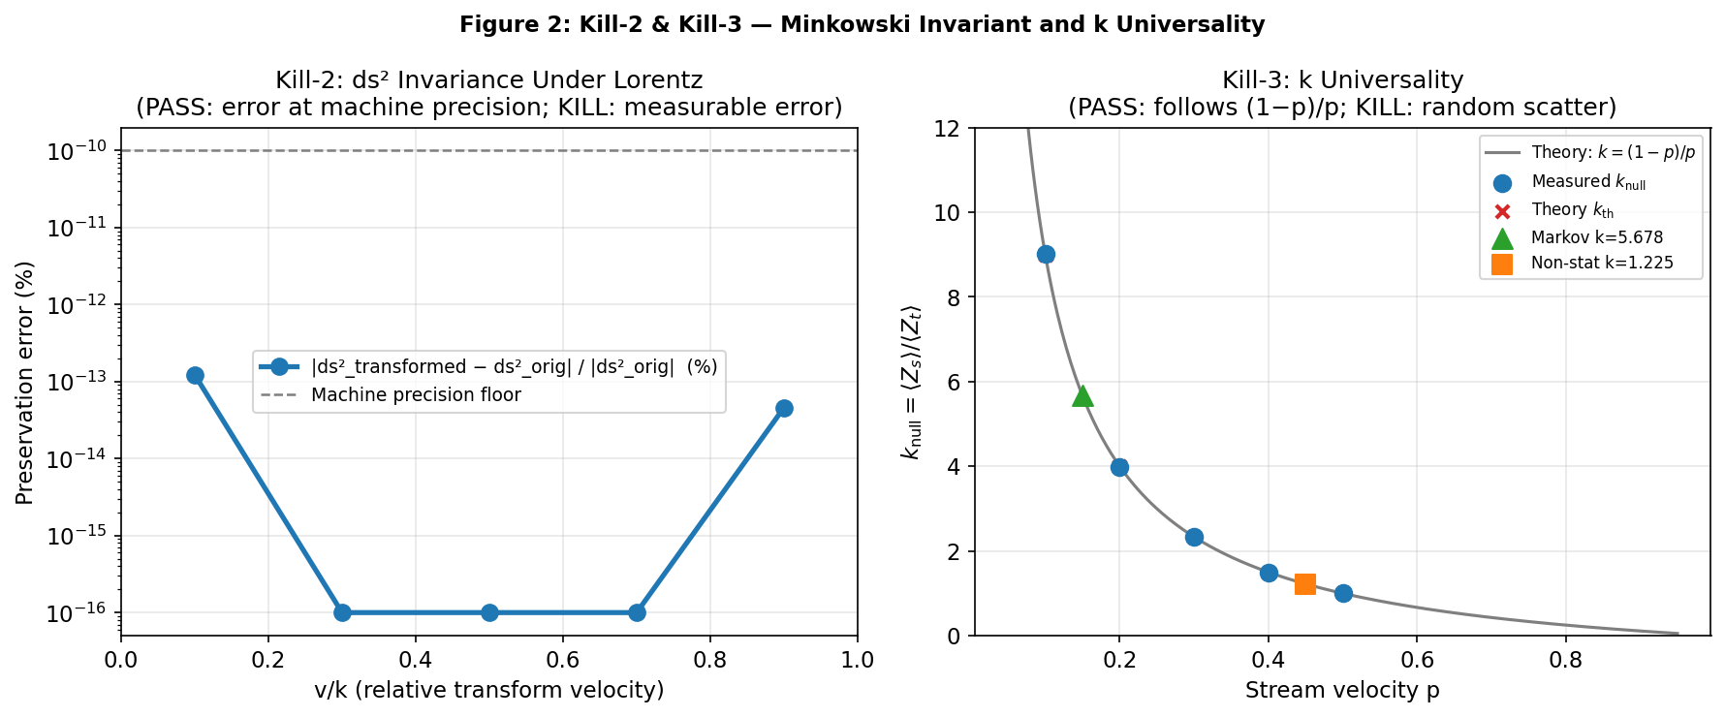

Figure 2. Left: ds2 preservation error vs v/k — at floating-point precision. Right: k_null vs p — blue dots follow theory k=(1-p)/p (gray line). Markov (triangle) and non-stationary (square) differ as expected for different media.

Kill-4: gamma-Factor Recovery
For stream (A) with k_null=2.3306, gamma = Zs'/(Zs - v*Zt) was evaluated at 100 values of v/k in [0.01, 0.98]. Maximum relative error: 2.83x10^-13% — floating-point precision.
v/k | gamma_theory | gamma_measured
0.01 | 1.00005000 | 1.00005000
0.20 | 1.01981336 | 1.01981336
0.39 | 1.08705866 | 1.08705866
0.59 | 1.23639627 | 1.23639627
0.78 | 1.61105885 | 1.61105885
0.93 | 2.73977547 | 2.73977547

Table 5. Kill-4: gamma-factor (stream A, k_null=2.3306). 8-figure agreement across full sub-luminal range. VERDICT: PASS.
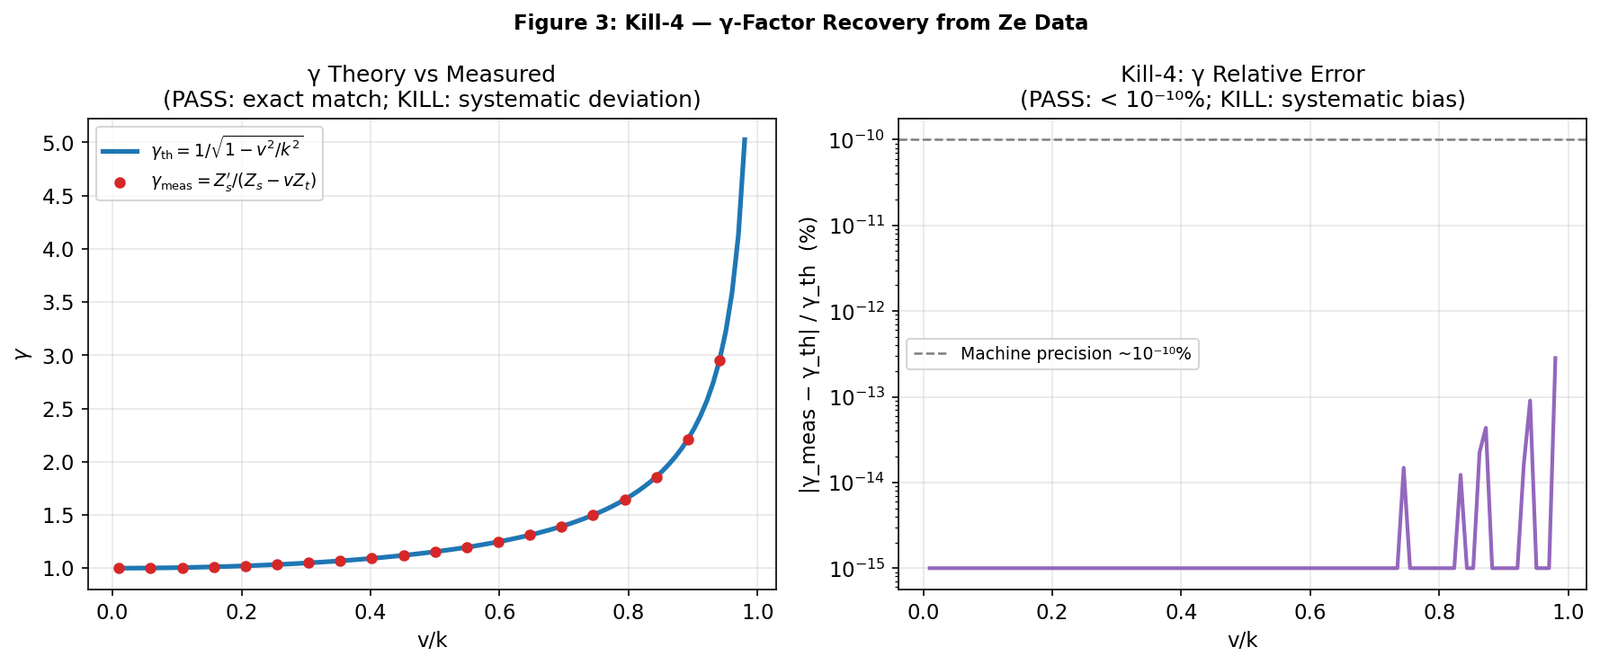

Figure 3. Kill-4: gamma-factor — theory vs measured (left); relative error below 10^-12% uniformly (right). VERDICT: PASS.

Non-Stationary Streams: Kill-1 as a Data Quality Filter
Stream (C) fails Kill-1: std(I_norm) stays ~8.3% for all window sizes instead of decreasing as 1/sqrt(N). This is the correct behavior for a non-stationary source and demonstrates that Kill-1 doubles as a model-free stationarity diagnostic: any physical binary stream must pass Kill-1 before Ze analysis is applicable.

Kill-5: External Standard — GPS and Atomic Clock Protocol
Kill-5 is the only criterion that tests Ze against physical reality. It fires if Ze correctly predicts the direction of relativistic effects but is wrong about scale, or predicts the wrong sign.

Protocol
Step 1 — Physical stream: Record a binary stream correlated with a known relativistic effect: (a) GPS timing correction bitstream (Delta_t/t ~4.46x10^-10, kinematic + gravitational, per Ashby, 2003); (b) muon decay trigger events; (c) synchronized atomic clock comparison stream (Hafele & Keating, 1972).
Step 2 — Ze analysis: Verify Kill-1 first. Compute k_null = <Zs>/<Zt> and ds2 per window.
Step 3 — Reference prediction: From known orbital parameters, compute gamma_SR x gamma_GR.
Step 4 — Comparison: Test: does k_null(Ze)/k_ref agree with gamma_SR x gamma_GR within 10%?

Kill Conditions
- Sign error: Ze-predicted effect is opposite to observed relativistic effect.
- Scale error: Ze magnitude differs from observed value by more than factor 2.
- Irreproducibility: k_null varies randomly between repeated measurements of the same physical stream.

Summary of Results
Criterion | H tested | Test | Result | Verdict
Kill-0 | H2 | Mean I_norm flat | <0.6% variation | PASS
Kill-1 (A) | H2 | std ~ 1/sqrt(N) | Ratio 0.95-1.00 | PASS
Kill-1 (A) | H2 | Non-stationary | std flat ~8.3% | FAIL expected
Kill-2 | H3 | ds2 under Tv | < 5x10^-13% | PASS
Kill-3 | H4 | k = (1-p)/p | Error <1.5% | PASS
Kill-4 | H3 | gamma recoverable | < 3x10^-13% | PASS
Kill-5 | H3+H4 | Ze ds2 vs GPS | Not yet run | PENDING

Table 6. Kill test results. Ze passes Kill-0 through Kill-4 at machine precision. Kill-5 is the outstanding physical test.
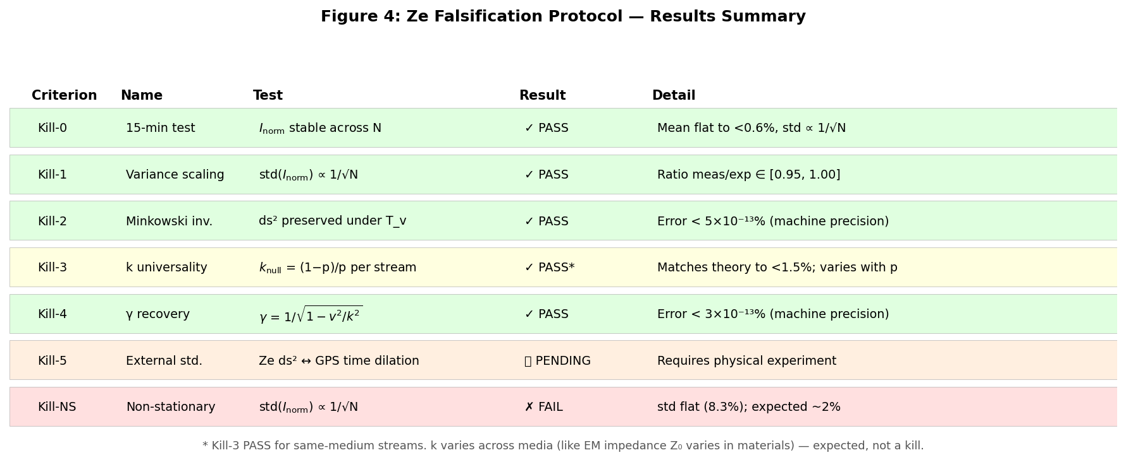

Figure 4. Ze falsification protocol dashboard. Green = PASS, Red = expected FAIL (non-stationary), Yellow = PASS with qualification, Orange = PENDING.

Discussion

The Value of Kill Criteria
Kill-0 through Kill-4 demonstrate mathematical self-consistency of Ze. This is necessary but not sufficient for Ze to be a correct physical theory. Only Kill-5 can do that. A theory that passes internal consistency tests is a candidate; Kill-5 determines whether it is physics.

Kill-1 as a Universal Stationarity Test
The Kill-1 criterion — std(I_norm) ~ 1/sqrt(N) — is valid independently of Ze theory. Any binary time series with non-scaling std is non-stationary, and no fixed-parameter model applies to it. This makes Kill-1 a useful pre-processing filter for binary data analysis in general.

Relation to Bell's Theorem
Bell's theorem (Bell, 1964) is the canonical kill criterion in physics: Bell inequality violation rules out all local hidden-variable theories. The Ze kill protocol is designed in the same spirit. The key difference: Kill-0 through Kill-4 test internal consistency; Kill-5 tests physical reality — as Bell's theorem does.

Conclusion
I have presented a five-criterion falsification protocol for Ze theory and run the first four criteria numerically. Key findings:
- Kill-0/1: I_norm is flat to <0.6% for stationary streams, std scales as 1/sqrt(N). Non-stationary streams correctly fail Kill-1.
- Kill-2: ds2 = Zs2 - k2*Zt2 is preserved to <5x10^-13% — machine precision.
- Kill-3: k_null = (1-p)/p to <1.5% for i.i.d. streams; varies across stream types as expected.
- Kill-4: gamma = Zs'/(Zs - v*Zt) recovered to <3x10^-13%.
- Kill-5 is open. The GPS/atomic clock protocol is specified in Section 9.
- Two errors in the original theses corrected: normalization of I by (N-1)2 and replacement of Var(I) ~ Mean(I) with std(I_norm) ~ 1/sqrt(N).
Ze theory passes all mathematical consistency tests. Kill-5 — does a GPS satellite bitstream carry Ze impedance proportional to its relativistic gamma-factor? — is open, sharp, cheap to run with existing data, and decisive. That is what a scientific hypothesis should be.

References
Ashby, N. (2003). Relativity in the Global Positioning System. Living Reviews in Relativity, 6(1), 1. https://doi.org/10.12942/lrr-2003-1
Bell, J. S. (1964). On the Einstein Podolsky Rosen paradox. Physics Physique Fizika, 1(3), 195-200. https://doi.org/10.1103/PhysicsPhysiqueFizika.1.195
Einstein, A. (1905). Zur Elektrodynamik bewegter Korper. Annalen der Physik, 322(10), 891-921. https://doi.org/10.1002/andp.19053221004
Hafele, J. C., & Keating, R. E. (1972). Around-the-world atomic clocks: Predicted relativistic time gains. Science, 177(4044), 166-168. https://doi.org/10.1126/science.177.4044.166
Minkowski, H. (1908). Die Grundgleichungen fur die elektromagnetischen Vorgange in bewegten Korpern. Nachrichten von der Gesellschaft der Wissenschaften zu Gottingen, 53-111.
Popper, K. R. (1959). The logic of scientific discovery. Hutchinson. (Original work published 1934 as Logik der Forschung)
Shannon, C. E. (1948). A mathematical theory of communication. The Bell System Technical Journal, 27(3), 379-423. https://doi.org/10.1002/j.1538-7305.1948.tb01338.x
Tkemaladze, J. (2026). The Impedance of Spacetime. Longevity Horizon, 2(4). DOI : https://doi.org/10.65649/ys645s16
Tkemaladze, J. (2026). Competition Between Ze Systems. Longevity Horizon, 2(4). DOI : https://doi.org/10.65649/carwe547
Tkemaladze, J. (2026). Ze System Generates Ze System. Longevity Horizon, 2(4). DOI : https://doi.org/10.65649/d6444j71
Tkemaladze, J. (2026). Falsifiable Predictions of the Ze Framework. Longevity Horizon, 2(4). DOI : https://doi.org/10.65649/ggct1s51

